Name: Mriganka Patra

Email: [mriganka.patra@cognizant.com](mailto:mriganka.patra@cognizant.com)

Emp ID: 2415820

Day 18

Sprint 1 Submission

Task 1.2: As a CRM user, I want to see the age of a contact calculated from their birthday so that I can segment users by age group.

1. Go to object Manager
3. 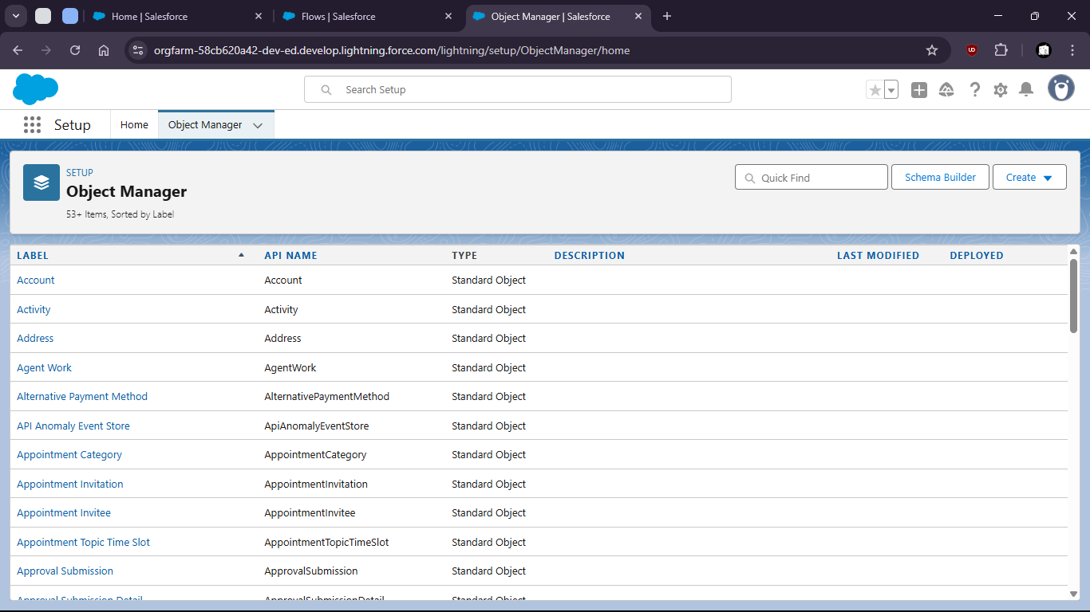
5. Select Contact object
7. 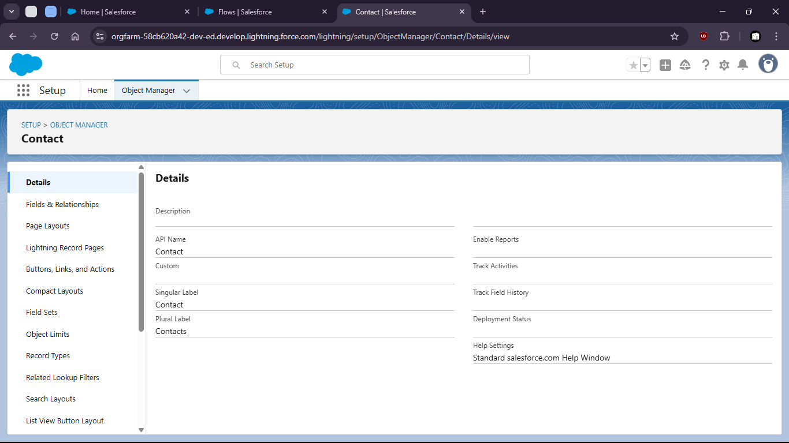
9. Go to the fields and relationships
11. 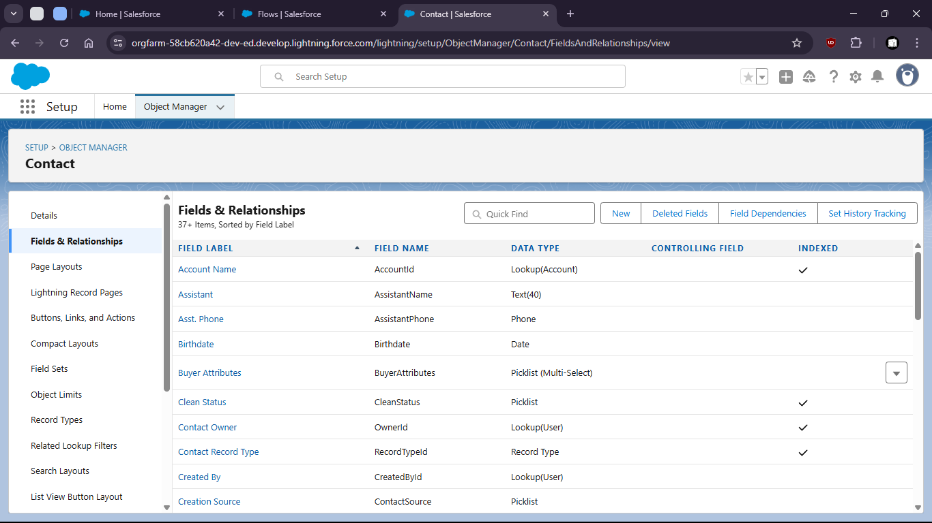
12. Create a new Field as Formula
14. 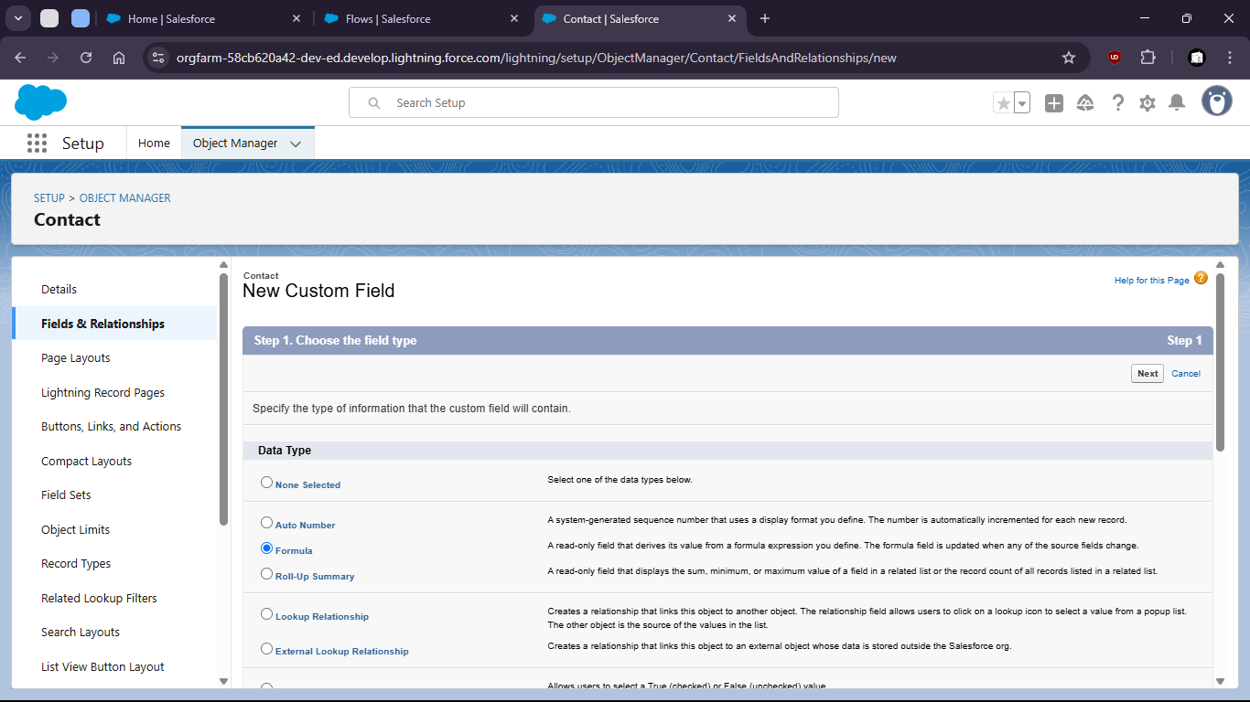
16. Give name and type
18. 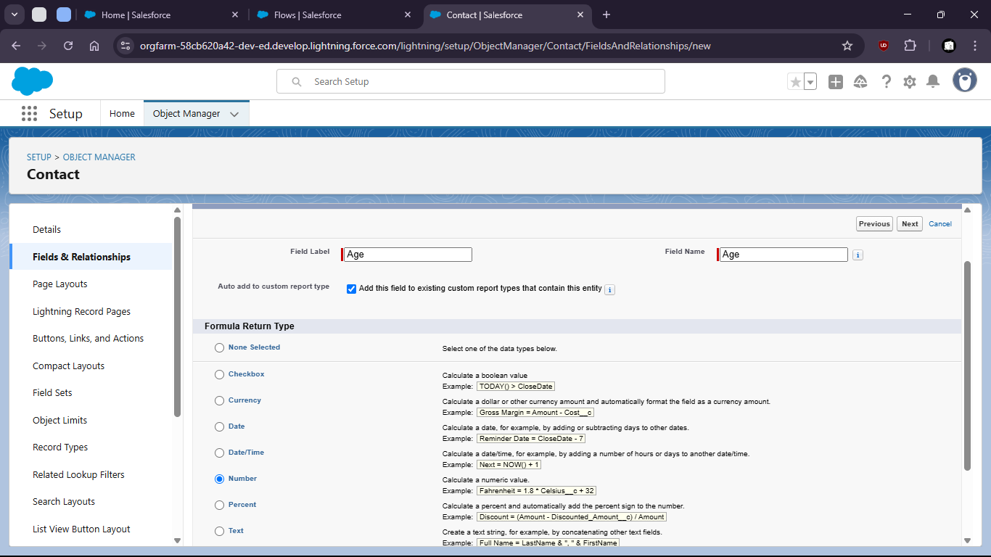
20. Enter the formula with proper syntax
22. 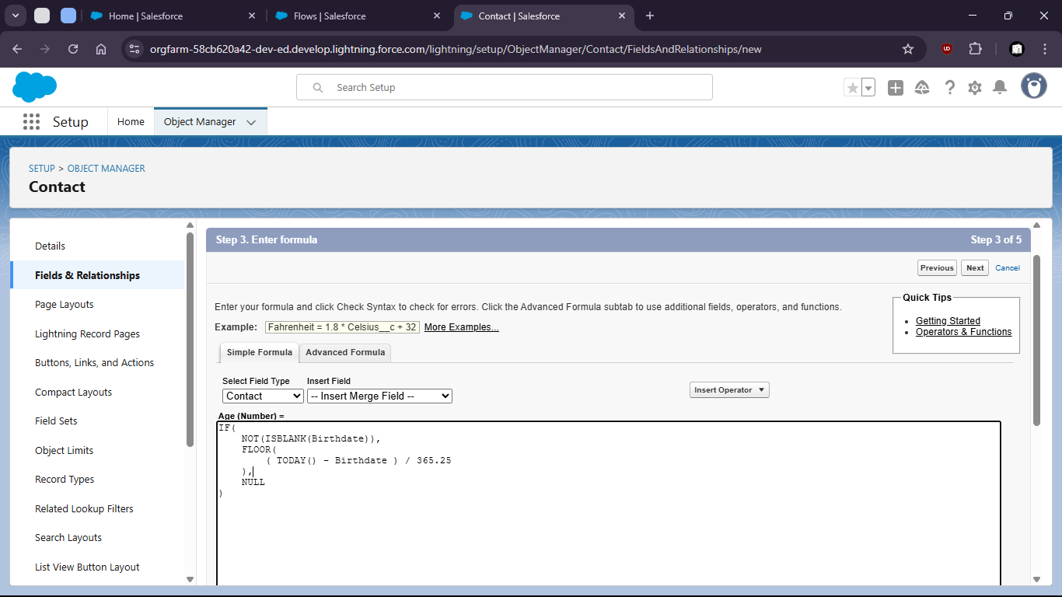
24. Setup field level security and save
26. 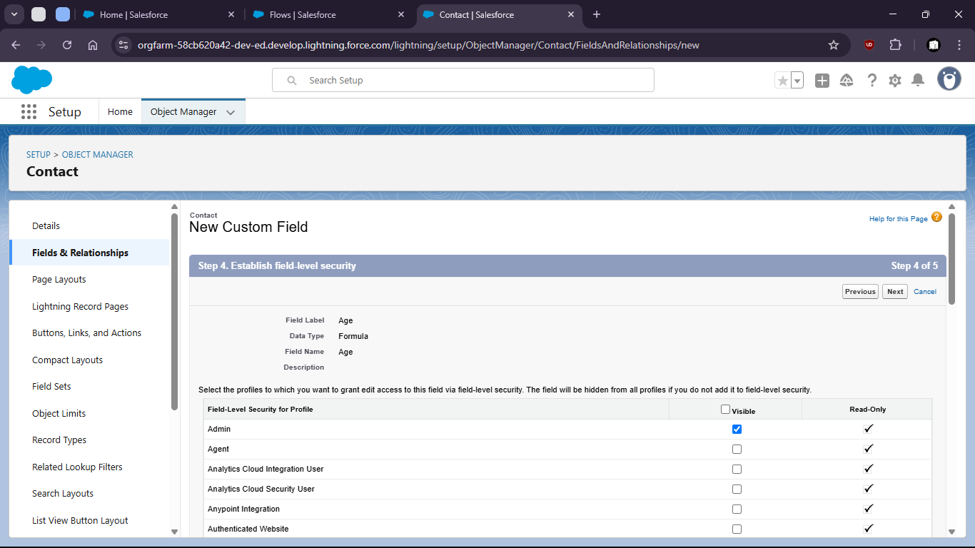
28. 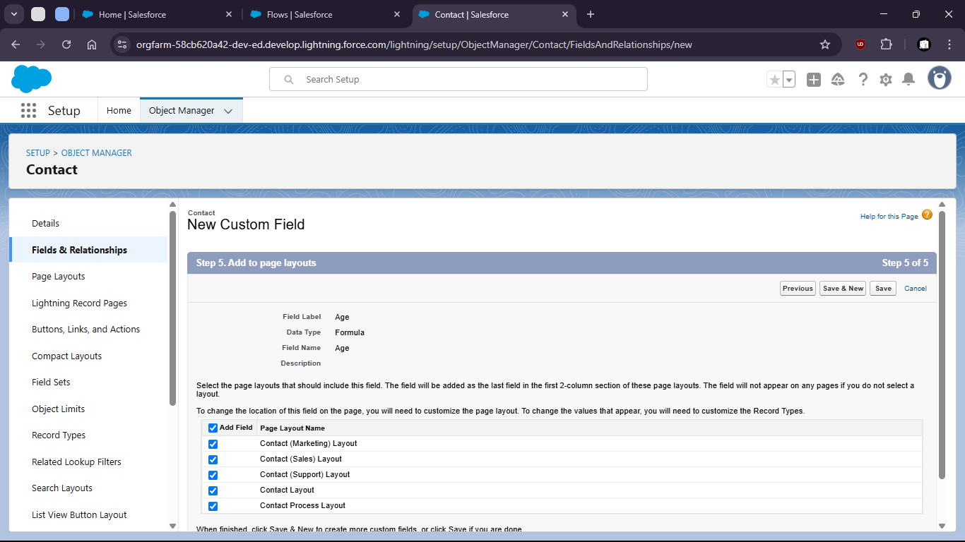
30. 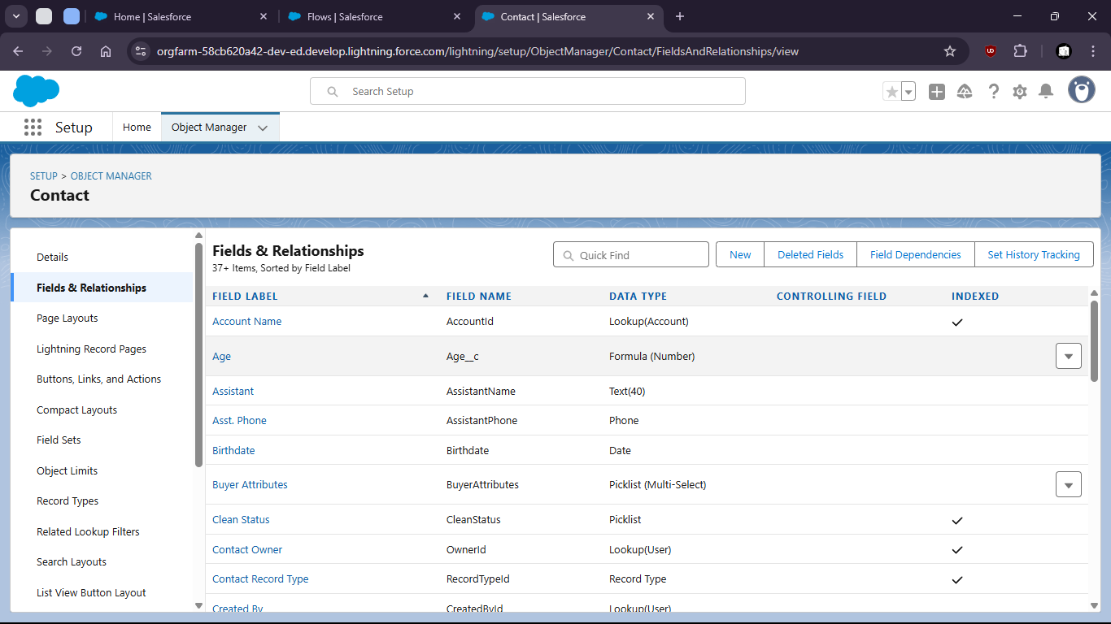
32. Now verify the field is working or not.
34. Go to contacts > create new contacts
36. 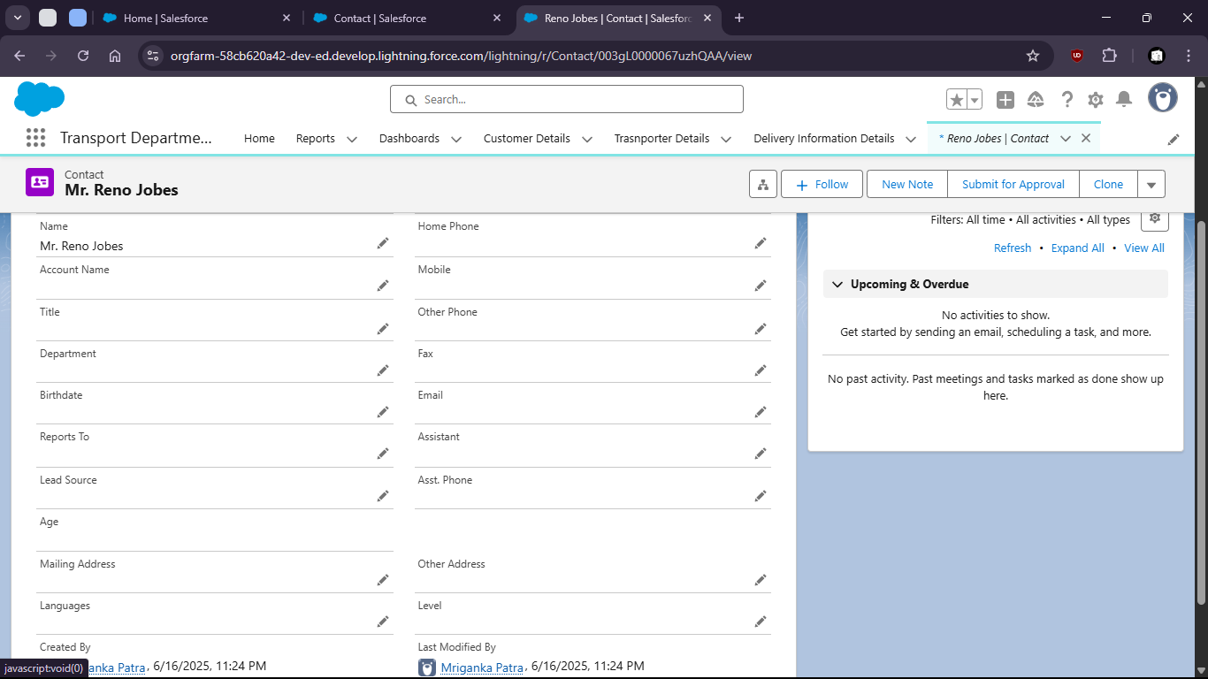
37. When no Birthdate given the age shows empty (NULL)
39. But when we put a Birthdate the age is calculated
41. 